



RWAV Ultimate Strategic Toolkit
Strategic Planning Framework & Implementation Guide

Rural Workforce Agency Victoria - Connecting Health Professionals with Rural Communities
© 2025 Carla Taylor t/as Carlorbiz Consulting. All Rights Reserved.
Individual Textbox System™ Methodology | Evidence-Based Strategic Planning

Project Information & Contact Details
Organisation Name *

Contact Person Name *

Email Address *

Phone Number


Position/Title
Project Timeframe
Start Date:
End Date:
Brief Project Description
Describe the strategic planning project, key objectives, and expected outcomes...

mm/dd/yyyy

mm/dd/yyyy

Strategic Research Questions

Define key questions that will guide your strategic planning process and evidence gathering for rural health workforce development.

- How can RWAV evolve from the traditional "bums on seats" model to addressing broader systemic issues affecting rural health communities?

Consider systemic challenges, community needs, and innovative approaches to rural health workforce development...

- What community-based approach would enable RWAV to work with rural towns to design their own health workforce solutions?
Explore community engagement strategies, local ownership models, and participatory design approaches...

- How can RWAV leverage its position as a trusted, independent organisation to advocate for system-level changes (internet, housing, education, infrastructure)?
Consider advocacy strategies, policy influence opportunities, and partnership approaches...

- What partnerships with business chambers, local councils, and community stakeholders could address the socio-economic determinants of health?
Identify potential partners, collaborative models, and multi-sector approaches...

- How can RWAV commission or conduct pilot programs to generate evidence-based rural health workforce models?

6. What would it take for rural Victoria to skip a generation of progress and become Australia's most innovative health workforce hub?
Envision transformational changes, breakthrough innovations, and game-changing initiatives...
Outline pilot program concepts, research methodologies, and evidence generation strategies...

Stakeholder Analysis & Power-Interest Matrix
Map key stakeholders and analyse their power and interest levels to inform engagement strategies.


High Power, Low Interest
Keep Satisfied
Examples: Department of Health Victoria, Medical Board of Australia

High Power, High Interest
Manage Closely
Examples: RWAV Board & Executive Team, Regional Health Services & Networks, State & Federal Health Departments, University Partners

List stakeholders with high power but low interest in your project...
List stakeholders with high power and high interest in your project...

Low Power, Low Interest
Monitor
Examples: General Public, Urban Health Networks

List stakeholders with low power and low interest in your project...

Low Power, High Interest
Keep Informed
Examples: Rural Health Students & Trainees, Rural Families & Community Members, Business Chambers & Local Economic Groups, Community Health Advocates

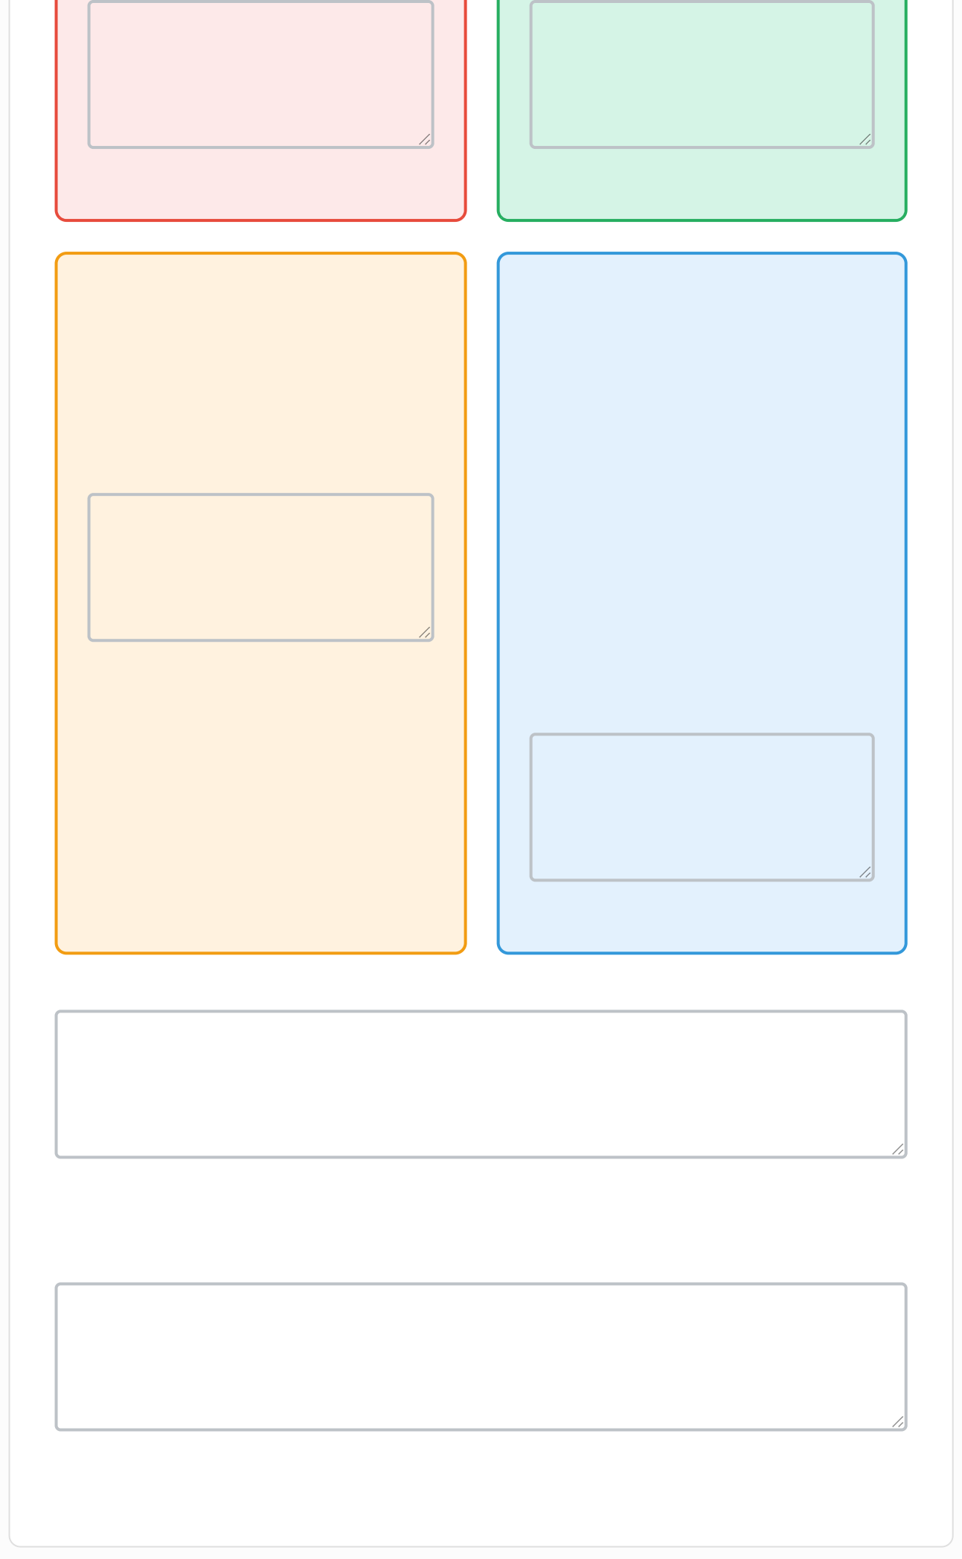

List stakeholders with low power but high interest in your project...

Additional Stakeholders or Special Considerations

Identify any additional stakeholders not captured above or special engagement considerations...

Overall Engagement Strategy

Describe your overall approach to stakeholder engagement based on the analysis above...

Strategic Partnership Framework

Develop and manage strategic partnerships to enhance rural health workforce outcomes.

Key Partner Types (Select all that apply)

Universities (Research & Evidence Generation Partners)
Regional Health Networks & Services

Local Government Authorities & Councils
Business Chambers & Economic Development Groups

Professional Colleges & Health Associations
Community Development Organisations

Partnership Activities (Select all that apply)

Community-designed health workforce solution development
Evidence-based pilot program commissioning and delivery

System-level advocacy for infrastructure improvements
Hub-and-spoke health service model facilitation

Multi-sector community development initiatives
Data-driven policy advocacy and research


Specific Partnership Opportunities
Describe specific partnership opportunities, existing relationships to leverage, or new partnerships to develop...



Partnership Priority Ranking
Rank your top 5 partnership priorities and explain your reasoning...

Strategic Template Selection & Content
Select and complete strategic planning templates to visualise your strategic thinking.

Select Templates to Complete (Choose all that apply)

SWOT Analysis Business Model Canvas

Stakeholder Impact Map Theory of Change

Risk Assessment Matrix Scenario Planning

SWOT Analysis
Analyse Strengths, Weaknesses, Opportunities, and Threats

Strengths Weaknesses
Internal positive factors that give competitive advantage...
Internal factors that may hinder performance...

Opportunities Threats

External factors that could provide advantages...
External factors that could pose challenges...

Business Model Canvas
Map your organisation's business model components

Key Partners
Key Activities
Key Resources

Who are your key partners and suppliers?
What key activities does your value proposition
What key resources does your value proposition

Value Propositions

What value do you deliver to customers?
Customer Relationships

What type of relationship do you establish with
Channels

Through which channels do you reach customers?



Customer Segments

Who are you creating value for?
Cost Structure

What are the most important costs in your model?
Revenue Streams

For what value are customers willing to pay?


Theory of Change
Map inputs, activities, outputs, outcomes, and impact

Inputs
What resources (human, financial, material) are needed?

Activities
What will you do with the inputs?

Outputs
What are the direct products of your activities?

Outcomes
What changes result from your outputs?

Impact


What is the long-term change you seek to achieve?

Risk Assessment Matrix
Assess risks by likelihood and impact

Risk Description | Likelihood (1-5) | Impact (1-5) | Risk Score | Mitigation Strategy
Describe the risk... | Sel |  | L×I | How will you mitigate this
Describe the risk... | Sel |  | L×I | How will you mitigate this
Describe the risk... | Sel |  | L×I | How will you mitigate this

Scenario Planning
Explore best, worst, and most likely scenarios

Best Case
Scenario
Worst Case
Scenario
Most Likely
Scenario
Upload Completed Templates
Choose Files No file chosen
Upload any completed strategic planning templates, diagrams, or
supporting documents.
Describe the most realistic outcome...
Describe the worst possible outcome...
Describe the best possible outcome...

Implementation Planning

Define priorities, timelines, and resources for successful implementation.

Strategic Priority Implementation Timeline

Level
Target Start:
Target Completion:

Select Priority Leve

mm/dd/yyyy

mm/dd/yyyy

Resource Requirements (Select all that apply)

Additional Staff/Human Resources
Additional Funding


Technology/Systems Training/Capacity Building




New Partnerships Governance/Policy Changes
Submit Your Strategic Planning
Work
Your responses will be compiled into a comprehensive strategic
planning document using Carlorbiz's Individual Textbox System™ methodology.
Submit Strategic Toolkit

Budget Considerations
Outline budget requirements, funding sources, and financial considerations...

Next Steps & Action Plan
Detail the immediate next steps, who will be responsible, and key milestones...

Success Metrics & Evaluation
How will you measure success? What are your key performance indicators?


This submission will be reviewed by Carla Taylor and the Carlorbiz strategic planning team.

